First of all, create a student model inside (models.py)

# Create your models here.

class Student(models.Model):

id = models.AutoField(primary_key=True)

name = models.CharField(max_length=200)

email= models.EmailField(max_length=200)

class Meta:

db_table = "students"

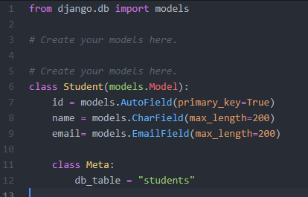

Now go the the admin.py file and register your created model here

from django.contrib import admin

from .models import Student

# Register your models here.

admin.site.register(Student)

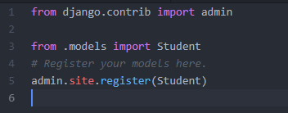

Now run this code

$ python manage.py makemigrations

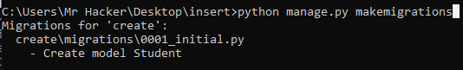

$ python manage.py migrate

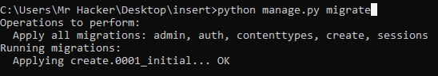

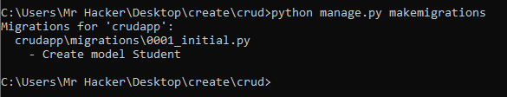

**Creating an admin user**

First, we’ll need to create a user who can login to the admin site. Run the following command:

$ python manage.py createsuperuser

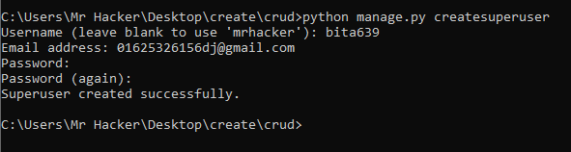

## Start the development server

The Django admin site is activated by default. Let’s start the development server and explore it.

Recall from Tutorial 1 that you start the development server like so:

$ python manage.py runserver

Now, open a Web browser and go to “/admin/” on your local domain – e.g., <http://127.0.0.1:8000/admin/>. You should see the admin’s login screen:

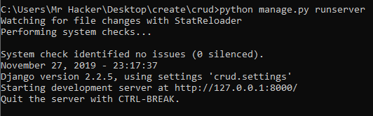

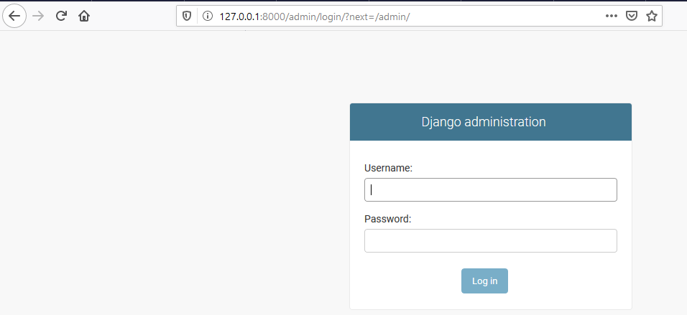

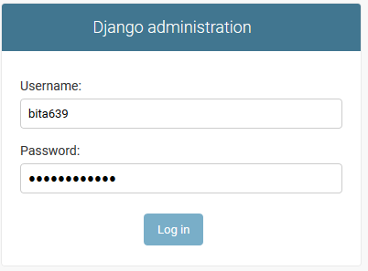

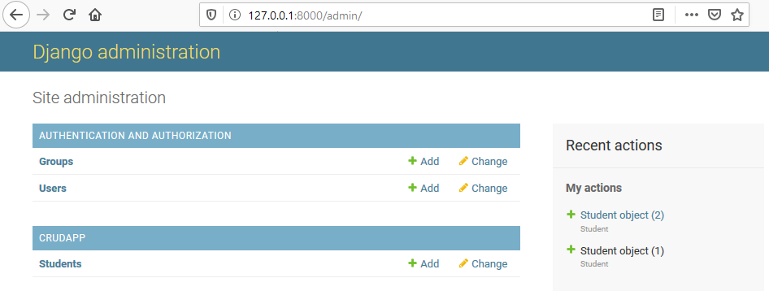

Now click on student and insert data

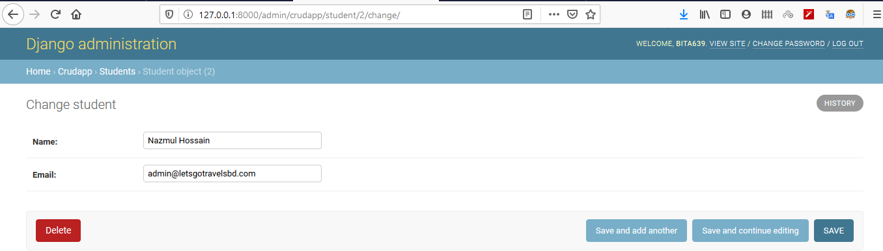

now go to index.html file and crate the view for fetching data.

<!DOCTYPE html>

<html lang="en">

<head>

<title>{{title}}</title>

<meta charset="utf-8">

<meta name="viewport" content="width=device-width, initial-scale=1">

<link rel="stylesheet" href="https://maxcdn.bootstrapcdn.com/bootstrap/3.4.0/css/bootstrap.min.css">

<script src="https://ajax.googleapis.com/ajax/libs/jquery/3.4.1/jquery.min.js"></script>

<script src="https://maxcdn.bootstrapcdn.com/bootstrap/3.4.0/js/bootstrap.min.js"></script>

</head>

<body>

<div class="container">

<h2>Bordered Table</h2>

<p>The .table-bordered class adds borders to a table:</p>

<table class="table table-bordered">

<thead>

<tr>

<th>Id</th>

<th>Name</th>

<th>Email</th>

</tr>

</thead>

<tbody>

{%for std in students %}

<tr>

<td>{{std.id}}</td>

<td>{{std.name}}</td>

<td>{{std.email}}</td>

</tr>

{% endfor %}

</tbody>

</table>

</div>

</body>

</html>

This is the code inside the index.html file

Now save the file and run the server to check

$ manage.py runserver

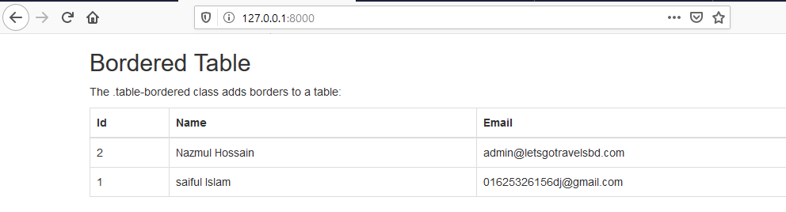

BOOM !!!!